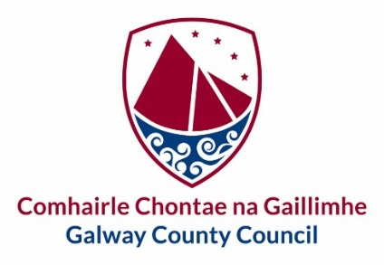
Oifig an Rúnaí,
Áras an Chontae,
Cnoc na Radharc,
Gaillimh.

6 Mhéan Fomhair 2021

Chuig an gCathaoirleach and gach Ball den Choiste um Beartas Straitéiseach - Athrú Aeráide
agus Bithéagsúlacht

To: The Chairman and Each Member of the Climate Change and Biodiversity Strategic Policy Committee

A Chara,
Iarrtar ort bheith i láthair ag Cruinniú den Choiste um Beartas Straitéiseach - Athrú Aeráide agus Bithéagsúlacht, a bheith á reáchtáil trí Teams agus a thionólfar Dé Céadaoin an 7 Deireadh Fomhair 2021 tosú ag 11.00 am.
You are hereby requested to attend a Meeting through Teams of the Climate Change and Biodiversity Strategic Policy Committee which will be held on Wednesday 7 October 2021 starting at 11.00 am.

Mise, le meas,

Maria Finn
Riarthóir Cruinnithe / Meetings Administrator
Tel. 087 9234911

C L Á R

- Confirmation of Minutes and Matters arising from Climate Change and Biodiversity Strategic Policy Committee Meeting held on 29 September 2021

- Biodiversity and Pollinators update

- Presentation from National Biodiversity Data Centre Ireland

- Biodiversity Story Maps

- Climate Action Plan

- Decarbonisation Zones

- AOB

- Date and Time of Next Meeting

